**9. DESIGN OF LOWPASS AND HIGHPASS FILTER**

**9.1 OBJECTIVE**

To design a low pass, high pass filter and plot the frequency response.

|  |  |  |  |
| --- | --- | --- | --- |
| **S.No** | **Equipment/Component name** | **Specifications/Value** | **Quantity** |
| 1 | IC 741 | Refer data sheet in appendix | 1 |
| 2 | Resistor | 3.3kΩ  5.8kΩ  10kΩ | 2  1  1 |
| 3 | Capacitor | 0.047uf | 2 |
| 4 | Cathode Ray Oscilloscope | (0 – 20MHz) 1 | 1 |
| 6 | Dual power supply | 15v | 1 |
| 7 | Function Generator | (0-2) MHz | 1 |

**9.2 THEORY**

A filter is a circuit that lets certain frequencies pass and blocks other frequencies. This selective nature can be done two ways, either with passive filters or with active filters. Passive filters completely comprised of passive elements; namely resistors, capacitors and/or inductors. Active filters use active devices, i.e., an op-amp, to filter out unwanted signals.

**Active filters have the following advantages over passive filters.**

* Gain and frequency adjustment and tuning.
* No inductors (reduces cost and size).
* No loading effects.

**Some disadvantages of active filters.**

* Bandwidth limitations
* Fabrication tolerances
* Can only respond to a specific range of signal magnitudes.

Figure 1 shows the performance of an practical low-pass and high pass circuit. Active filters can be classified as; low-pass, high-pass, band-pass, notch, or all pass circuit. These circuits are all used for different purposes, but this lab will focus on the design of second order low pass and high pass Filters.

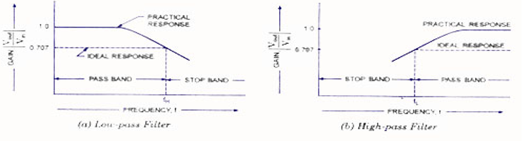

**Fig 1. Graph of practical (a) Low pass Filter and (b) High pass Filter**

**Design:**

Given fc=2KHz,

Choose C1=C2=0.047uF, fc=1/2πRC, R3=R4=3.3kΩ, R2=5.8kΩ, R1=10kΩ, α=3-A

Α=1.414 A=1.586

A=1+Rf/R1

**SECOND ORDER LOW PASS FILTER**

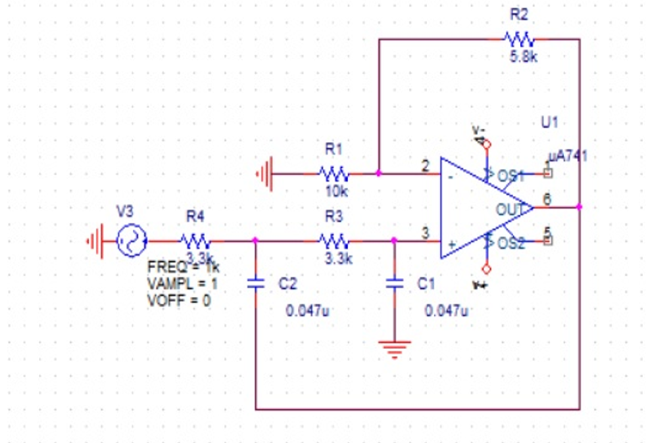

**Fig.2.Second-Order Low-Pass Filter**

**SECOND ORDER HIGH PASS FILTER**

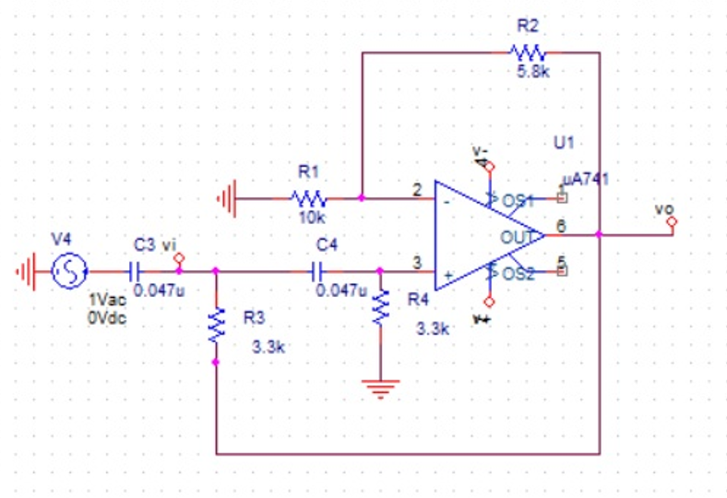

**Fig.3.Second-Order High-Pass Filter**

**9.3 EXPERIMENT**

**9.3.1 Low pass filter**

Design a Second order low pass filter as shown in figure 2 for the values R3 =R4 =3.3 K Ω R2=5.8K Ω, R1= 10KΩ C1=C2=0.47uF,for the sinusoidal input of amplitude 1V and plot the frequency response.

**9.3.2 High pass filter**

Design a Second order High pass filter as shown in figure 3 for the values R3 = R4=3.3KΩ, C3=C4=0.047uF, R2=5.8KΩ, R1=10KΩ for the sinusoidal input of amplitude 1V and plot the frequency response.

**9.4 TABULATION**

**9.4.1 Low Pass Filter**

**Vin =**

|  |  |  |  |  |
| --- | --- | --- | --- | --- |
| **S.No** | **Input Frequency fin** | **Output Amplitude Vo** | **Gain A = Vo/Vin** | **Gain(dB) = 20 log(A)** |
|  |  |  |  |  |

**9.4.2 High Pass Filter**

**Vin =**

|  |  |  |  |  |
| --- | --- | --- | --- | --- |
| **S.No** | **Input Frequency fin** | **Output Amplitude Vo** | **Gain A = Vo/Vin** | **Gain(dB) = 20 log(A)** |
|  |  |  |  |  |

**9.5 PRE-LAB**

1. Design a second order low pass butterworth filter at a high cut-off frequency of 2.2kHz. Given RF=20kΩ and capacitor 0.047µF.

2. How is the higher order filters formed?

3. The internal resistor of the second order high pass filter is equal to 10kΩ. Find the value of feedback resistor?

4. Given the lower and higher cut-off frequency of a band-pass filter are 2.5kHz and 10kHz. Determine its bandwidth.

**9.6 POST LAB QUESTION**

1. Compute the pass band gain and high cut-off frequency for the first order low pass filter.

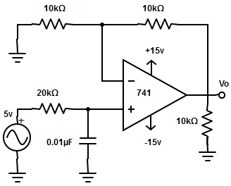

2. Determine voltage gain of second order high pass butterworth filter. Specifications R3 =R2=33Ω, f = 250hz and fL=1khz.

**RESULT**

Low pass and high pass filter were designed and their frequency response was plotted.

**10.    DESIGN OF BAND PASS FILTER AND BAND REJECT FILTER**

**10.1 OBJECTIVE**

To design a low pass, high pass, Band pass and Band stop filter and plot the frequency response.

|  |  |  |  |
| --- | --- | --- | --- |
| **S.No** | **Equipment/Component name** | **Specifications/Value** | **Quantity** |
| 1 | IC 741 | Refer data sheet in appendix | 1 |
| 2 | Resistor | 100KΩ,7.95KΩ | 2 |
| 3 | Capacitor | 0.01uf | 2 |
| 4 | Cathode Ray Oscilloscope | (0 – 20MHz) 1 | 1 |
| 6 | Regulated power supply | (0 -5V), 1A | 1 |
| 7 | Function Generator | (0-2) MHz | 1 |

**10.2    THEORY**

**BAND PASS FILTER**

The band pass filter passes one set of frequencies while rejecting all others. The band-stop filter does just the opposite. It rejects a band of frequencies, while passing all others. This is also called a band-reject or band-elimination filter. Like band pass filters, band-stop filters

may also be classified as (i) wide-band and (ii) narrow band reject filters.

The narrow band reject filter is also called a notch filter. Because of its higher Q, which exceeds 10, the bandwidth of the narrow band reject filter is much smaller than that of a wide band reject filter.

This cascading together of the individual low and high pass passive filters produces a low “Q-factor” type filter circuit which has a wide pass band. The first stage of the filter will be the high pass stage that uses the capacitor to block any DC biasing from the source. This design has the advantage of producing a relatively flat asymmetrical pass band frequency response with one half representing the low pass response and the other half representing high pass response as shown.

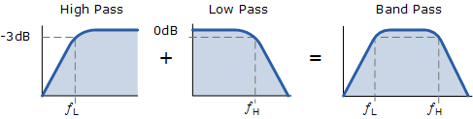

 The higher corner point ( ƒH ) as well as the lower corner frequency cut-off point ( ƒL ) are calculated the same as before in the standard first-order low and high pass filter circuits. Obviously, a reasonable separation is required between the two cut-off points to prevent any interaction between the low pass and high pass stages. The amplifier also provides isolation between the two stages and defines the overall voltage gain of the circuit.

The bandwidth of the filter is therefore the difference between these upper and lower -3dB points. For example, if the -3dB cut-off points are at 200Hz and 600Hz then the bandwidth of the filter would be given as: Bandwidth (BW) = 600 – 200 = 400Hz. The normalized frequency response and phase shift for an active band pass filter will be as follows.

While the above passive tuned filter circuit will work as a band pass filter, the pass band (bandwidth) can be quite wide and this may be a problem if we want to isolate a small band of frequencies. Active band pass filter can also be made using inverting operational amplifier. So by rearranging the positions of the resistors and capacitors within the filter we can produce a much better filter circuit as shown below. For an active band pass filter, the lower cut-off -3dB point is given by ƒC2 while the upper cut-off -3dB point is given by ƒC1.

### BAND-STOP (OR REJECT) FILTER.

A wide band-stop filter using a low-pass filter, a high-pass filter and a summing amplifier is shown in figure. For a proper band reject response, the low cut-off frequency fL of high-pass filter must be larger than the high cut-off frequency fH of the low-pass filter. In addition, the pass band gain of both the high-pass and low-pass sections must be equal.

**This is also called a notch filter**. It is commonly used for attenuation of a single frequency such as 60 Hz power line frequency hum. The most widely used notch filter is the twin-T network illustrated in fig. (a). This is a passive filter composed of two T-shaped networks. One T-network is made up of two resistors and a capacitor, while the other is made of two capacitors and a resistor. One drawback *of*above notch filter (passive twin-T network) is that it has relatively low figure of merit Q. However, Q of the network can be increased significantly if it is used with the voltage follower. Here the output of the voltage follower is supplied back to the junction of R/2 and 2 C.

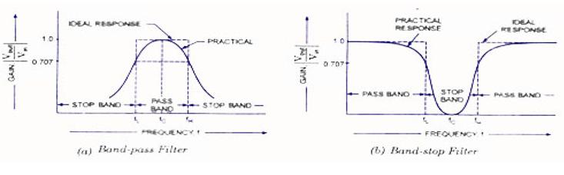

**Fig 1. Graph of practical (a) Band pass Filter and (b) Band stop Filter**

**Design:**

f1=1Khz

f’=10Khz

R1=10K Ω, C1=C2=0.04uF

fc=1/2πRC

A=1+Rf/R1

**Band Pass Filter**

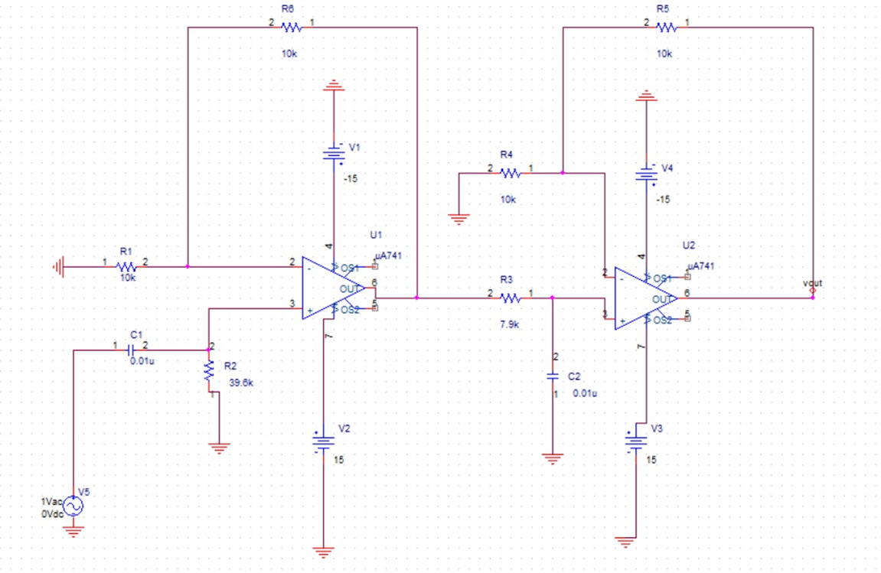

**Fig 2. Band Pass Filter**

**Band Stop Filter**

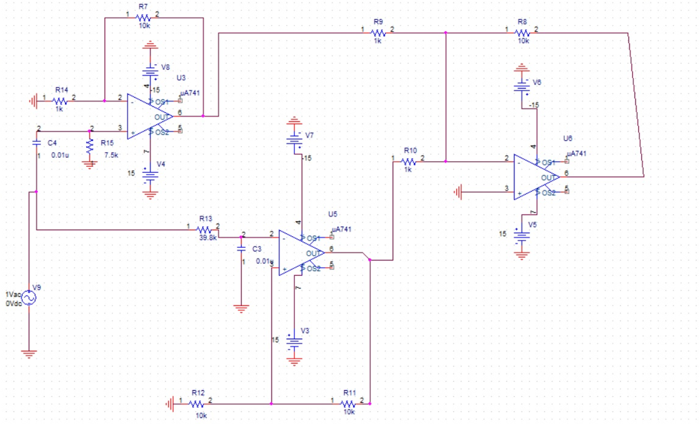

**Fig 3. Band Stop Filter**

**10.3.1 BAND PASS FILTER**

Design a Band Pass Filter as shown in figure 2 for the corresponding values as figure for the sinusoidal input of amplitude 1V and plot the frequency response.

**10.3.2 BAND STOP FILTER**

Design a Band Stop filter as shown in figure 3 for the corresponding values as in figure for the sinusoidal input of amplitude 1V and plot the frequency response.

**10.4 TABULATION**

**10.4.1 Band Pass Filter**

**Vin =**

|  |  |  |  |  |
| --- | --- | --- | --- | --- |
| **S.No** | **Input Frequency fin** | **Output Amplitude Vo** | **Gain A = Vo/Vin** | **Gain(dB) = 20 log(A)** |
|  |  |  |  |  |

**10.4.2 Band Stop Filter**

**Vin =**

|  |  |  |  |  |
| --- | --- | --- | --- | --- |
| **S.No** | **Input Frequency fin** | **Output Amplitude Vo** | **Gain A = Vo/Vin** | **Gain(dB) = 20 log(A)** |
|  |  |  |  |  |

**10.5    PRELAB**

1.    A band-pass filter has a bandwidth of 250Hz and center frequency of 866Hz. Find the quality factor of the filter?

2. Write the expression of wide band-pass filter center frequency.

3. Compute the quality factor of the wide band-pass filter with high and low cut-off frequencies equal to 950Hz and 250Hz.

**10.6     POSTLAB**

1.    The details of low pass filter are given as fh =10kHz, AF= 2 and f=1.2kHz. Find the voltage gain magnitude of first order wide band-pass filter, if the voltage gain magnitude of high pass filter section is 8.32dB.

2. Find the voltage gain magnitude of the wide band-pass filter? Where total pass band gain is=6, input frequency = 750Hz, Low cut-off frequency =200Hz and

high cut-off frequency=1khz.

**RESULT**

Low pass, high pass, Band pass and Band stop filter were designed and their frequency response was plotted.